5] (a)

#include<stdio.h>

int main(){

int n;

printf("Enter size of diagonal matrix: ");

scanf("%d",&n);

int diagonal[n];

printf("Enter diagonal elements:\n");

for(int i=0;i<n;i++)

scanf("%d",&diagonal[i]);

printf("Matrix:\n");

for(int i=0;i<n;i++) {

for(int j=0;j<n;j++)

printf("%d ",(i==j)? diagonal[i]:0);

printf("\n");}

return 0;}

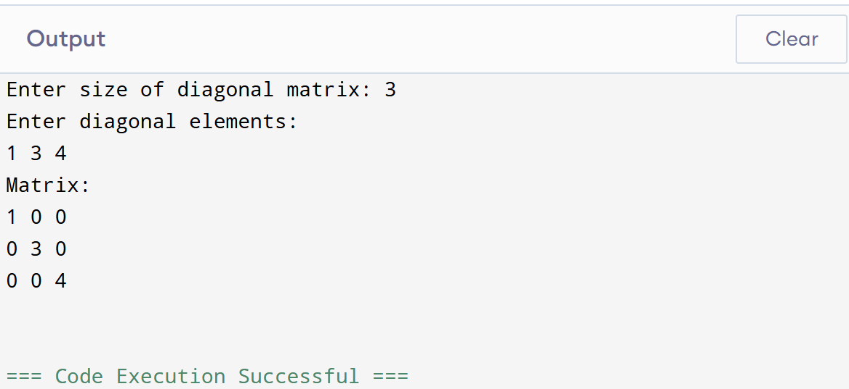

(b)

#include<stdio.h>

int main(){

int n;

printf("Enter size of tri-diagonal matrix: ");

scanf("%d",&n);

int lower[n-1],main[n],upper[n-1];

printf("Enter main diagonal:\n");

for(int i=0;i<n;i++) scanf("%d",&main[i]);

printf("Enter upper diagonal:\n");

for(int i=0;i<n-1;i++) scanf("%d",&upper[i]);

printf("Enter lower diagonal:\n");

for(int i=0;i<n-1;i++) scanf("%d",&lower[i]);

printf("Matrix:\n");

for(int i=0;i<n;i++){

for(int j=0;j<n;j++){

if(i==j) printf("%d ",main[i]);

else if(i==j-1) printf("%d ",upper[i]);

else if(i==j+1) printf("%d ",lower[j]);

else printf("0 ");

}

printf("\n");

}

return 0;

}

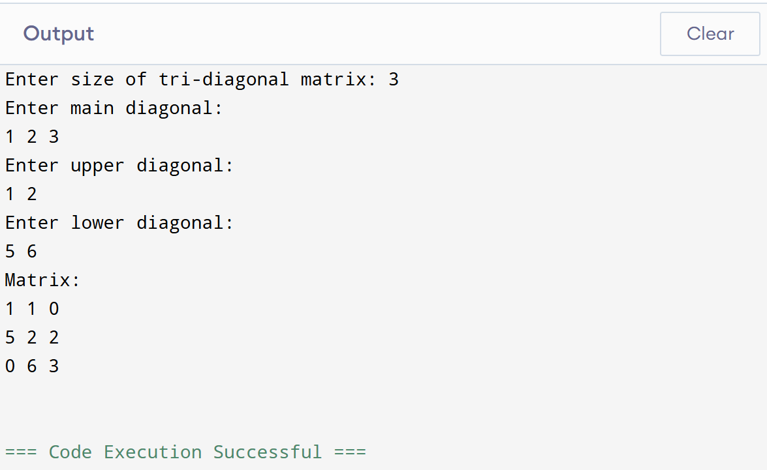

(c)

#include<stdio.h>

int main(){

int n;

printf("Enter size of lower triangular matrix: ");

scanf("%d",&n);

int size = n\*(n+1)/2;

int lower[size];

printf("Enter lower triangular elements:\n");

for(int i=0;i<size;i++) scanf("%d",&lower[i]);

printf("Matrix:\n");

int k=0;

for(int i=0;i<n;i++){

for(int j=0;j<n;j++){

if(i>=j) printf("%d ",lower[k++]);

else printf("0 ");

}

printf("\n");

}

return 0;

}

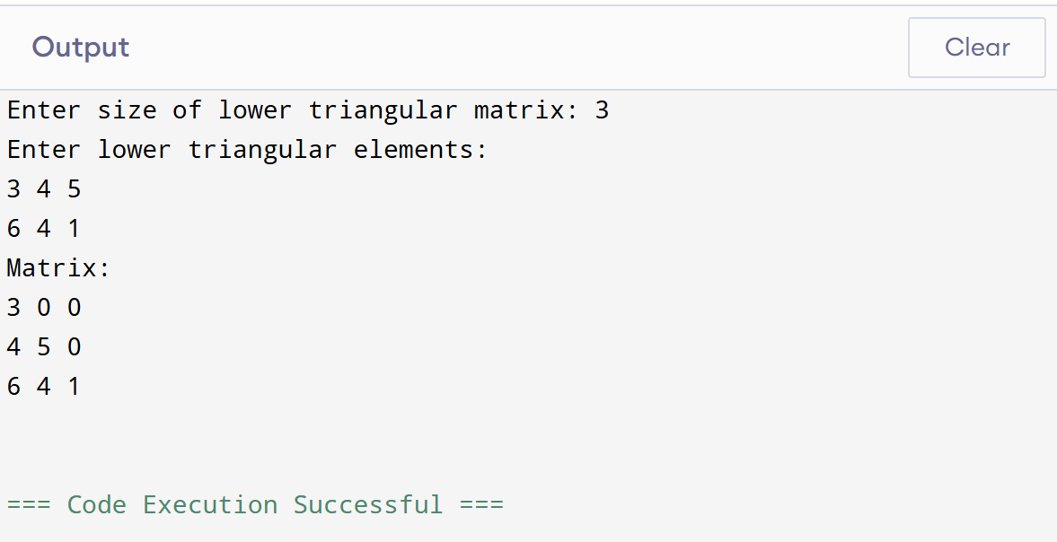

(d)

#include<stdio.h>

int main(){

int n;

printf("Enter size of upper triangular matrix: ");

scanf("%d",&n);

int size = n\*(n+1)/2;

int upper[size];

printf("Enter upper triangular elements:\n");

for(int i=0;i<size;i++) scanf("%d",&upper[i]);

printf("Matrix:\n");

int k=0;

for(int i=0;i<n;i++){

for(int j=0;j<n;j++){

if(i<=j) printf("%d ",upper[k++]);

else printf("0 ");

}

printf("\n");

}

return 0;

}

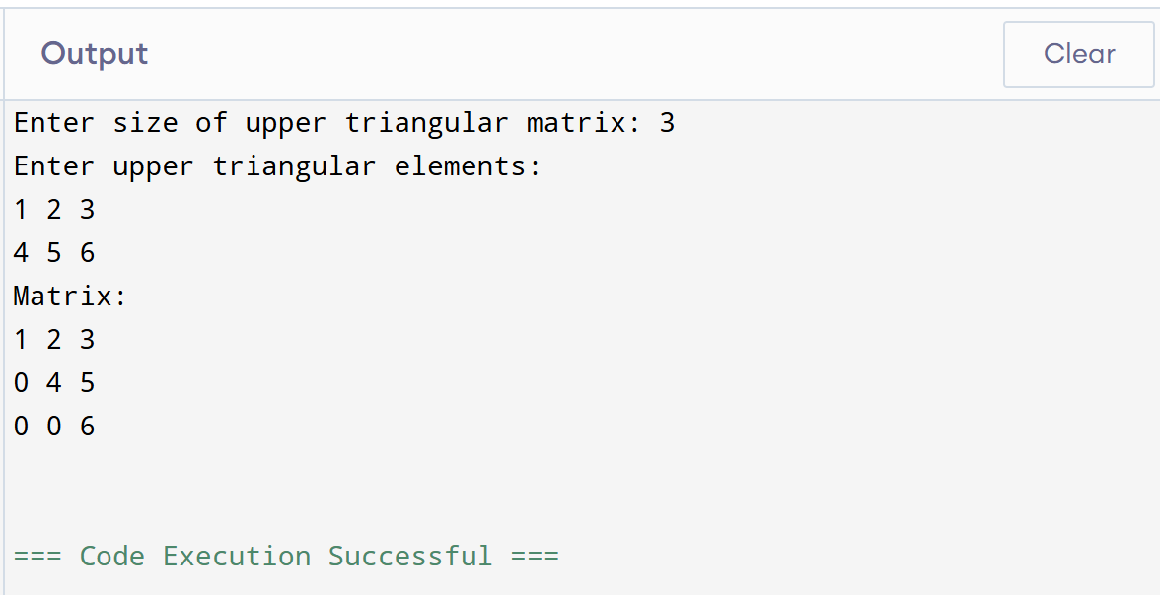

(e)

#include<stdio.h>

int main(){

int n;

printf("Enter size of symmetric matrix: ");

scanf("%d",&n);

int size = n\*(n+1)/2;

int symmetric[size];

printf("Enter upper triangular elements row-wise:\n");

for(int i=0;i<size;i++) scanf("%d",&symmetric[i]);

printf("Matrix:\n");

int k;

for(int i=0;i<n;i++){

k = i\*(i+1)/2;

for(int j=0;j<n;j++){

if(i<=j){ int index = j\*(j+1)/2+i;

printf("%d ",symmetric[index]);

} else { int index = i\*(i+1)/2+j;

printf("%d ",symmetric[index]);

}

}

printf("\n");

}

return 0;

}

